Chapter 1

Data Modeling using Entity Relatioship (E-R) Diagram

Contents

- Conceptual Data Model for Database Design
- ER Model Concepts
  - Entities and Attributes
  - Entity Types, Value Sets, and Key Attributes
  - Relationships and Relationship Types
  - Weak Entity Types
  - Roles and Attributes in Relationship Types
- ER Diagrams - Notation
Overview of Database
- Two main activities:
  - Database design
  - Applications design
- Focus in this chapter on database design
  - To design the conceptual schema for a database application
- Applications design focuses on the programs and interfaces that access the database
  - Generally considered part of software engineering

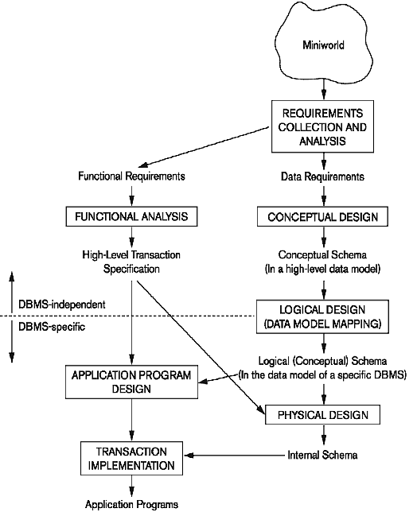
Entity-Relationship (ER) Model Concepts
- A popular high-level conceptual data model
- Entities and Attributes
  - Entities are specific objects or things in the mini-world that are represented in the database.
    - For example the EMPLOYEE John Smith, the Research DEPARTMENT, the ProductX PROJECT
  - Attributes are properties used to describe an entity.
    - For example an EMPLOYEE entity may have the attributes Name, SSN, Address, Gender, BirthDate
  - A specific entity will have a value for each of its attributes.
    - For example a specific employee entity may have Name='John Smith', SSN='123456789', Address ='731, Fondren, Houston, TX', Gender='M', BirthDate='09-JAN-55‘
  - Each attribute has a value set (or data type) associated with it – e.g. integer, string, subrange, enumerated type, etc

Types of Attributes
- Simple
  - Each entity has a single atomic value for the attribute. For example, SSN or Gender.
- Composite
  - The attribute may be composed of several components. For example:
    - Address(Apt#, House#, Street, City, State,
ZipCode, Country), or
    - Name(FirstName, MiddleName, LastName).
    - Composition may form a hierarchy where some components are themselves composite.
- Multi-valued
  - An entity may have multiple values for that attribute. For example, Color of a CAR or PreviousDegrees of a STUDENT.
    - Denoted as {Color} or {PreviousDegrees}.

Example of a Composite Attribute

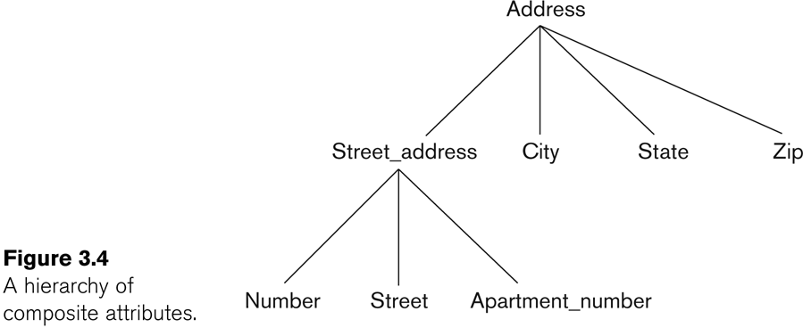

- In general, composite and multi-valued attributes may be nested arbitrarily to any number of levels, although this is rare.
  - For example, PreviousDegrees of a STUDENT is a composite multi-valued attribute denoted by {PreviousDegrees (College, Year, Degree, Field)}
  - Multiple PreviousDegrees values can exist
  - Each has four subcomponent attributes:
    - College, Year, Degree, Field
- Complex Attributes
  - Nested composite and multivalued attributes
    - Ex. A person has more than one residence and each residence can have a single address and multiple phones

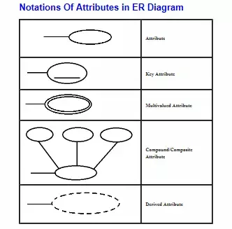

Stored and Derived Attributes

An derived attribute is derived from a stored attribute

Ex. We can derive a man’s age
from his birthday.
Null Values -
Its meaning includes
  - An attribute value is not applicable
  - An attribute value is unknown
    - The value exists but is missing
    - The value is unknown whether it exists
Entity Types and Key Attributes
- Entities with the same basic attributes are grouped or typed into an entity type.
  - For example, the entity type EMPLOYEE and PROJECT.
- An attribute of an entity type for which each entity must have a unique value is called a key attribute of the entity type.
  - For example, SSN of EMPLOYEE.
- A key attribute may be composite.
  - VehicleTagNumber is a key of the CAR entity type with components (Number, State).
- An entity type may have more than one key.
  - The CAR entity type may have two keys:
    - VehicleIdentificationNumber (popularly called VIN)
    - VehicleTagNumber (Number, State), aka license plate number.
- Each key is underlined

Displaying an Entity Type

- In ER diagrams, an entity type is displayed in a rectangular box
- Attributes are displayed in ovals
  - Each attribute is connected to its entity type
  - Components of a composite attribute are connected to the oval representing the composite attribute
  - Derived attributes are denoted by dotted ovals
  - Each key attribute is underlined
  - Multivalued attributes displayed in double ovals
- See CAR example below
- Entity Type CAR with two keys and a corresponding Entity Set

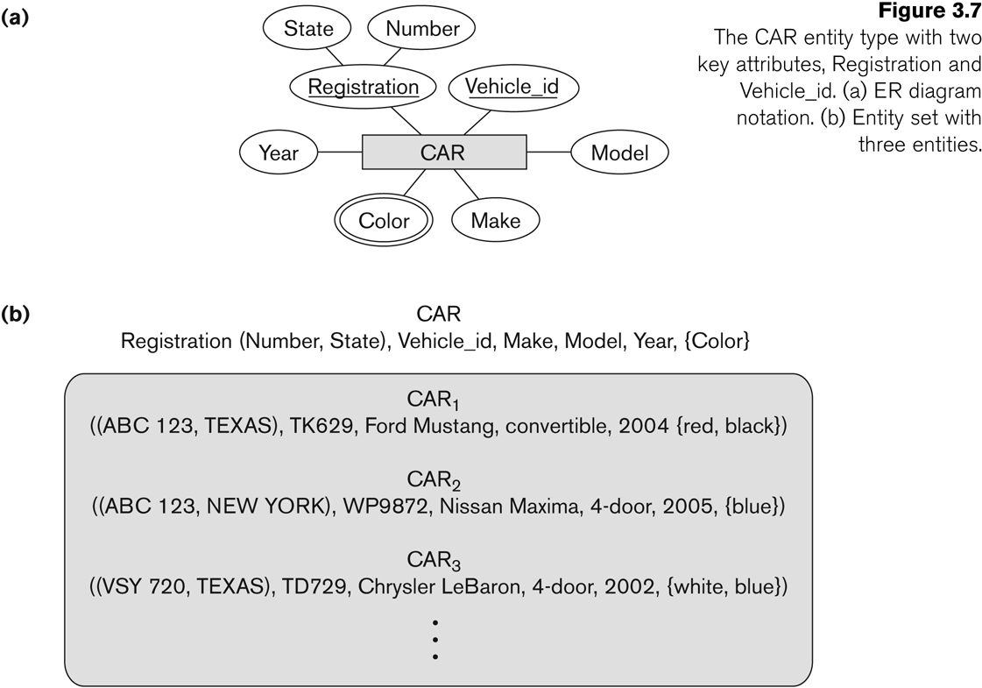
Entity Set Value Sets (Domains) of Attributes

- Each entity type will have a collection of entities stored in the database
  - Called the entity set (also called the
extension of the entity type)
  - An entity type describes the schema or
intension for a set of entities
- Previous slide shows three CAR entity
instances in the entity set for CAR
- Same name (CAR) used to refer to both the entity type and the entity set
- Entity set is the current state of the entities of that type that are stored in the database
- Each simple attribute is associated with a value set (or domain of values)
  - Ex. The Age attribute of EMPLOYEE to be the set of integer numbers between 16 to 70

Initial Design of Entity Types for the COMPANY Database Schema

- Based on the requirements, we can identify four initial entity types in the COMPANY database:
  - DEPARTMENT
  - PROJECT
  - EMPLOYEE
  - DEPENDENT
- Their initial design is shown on the following slide
- The initial attributes shown are derived from the requirements description

Initial Design of Entity Types:

EMPLOYEE, DEPARTMENT, PROJECT, DEPENDENT

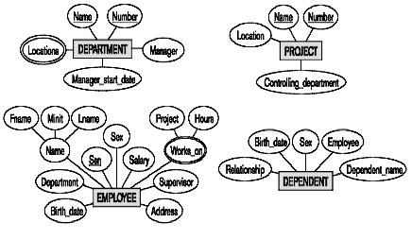

Refining the Initial Design by Introducing Relationships

- The initial design is typically not complete
- Some aspects in the requirements will be represented as relationships
- ER model has three main concepts:
  - Entities (and their entity types and entity sets)
  - Attributes (simple, composite, multivalued)
  - Relationships (and their relationship types and relationship sets)
- We introduce relationship concepts next
Relationships and Relationship Types

- A relationship relates two or more distinct entities with a specific meaning.
  - For example, EMPLOYEE John Smith works on the ProductX PROJECT, or EMPLOYEE Franklin Wong manages the Research DEPARTMENT.
- Relationships of the same type are grouped or typed into a relationship type.
  - For example, the WORKS_ON relationship type in which EMPLOYEEs and PROJECTs participate, or the MANAGES relationship type in which EMPLOYEEs and DEPARTMENTs participate.
- The degree of a relationship type is the number of participating entity types.
  - Both MANAGES and WORKS_ON are binary relationships.
Relationship Instances of the WORKS_FOR N:1

Relationship between EMPLOYEE and DEPARTMENT
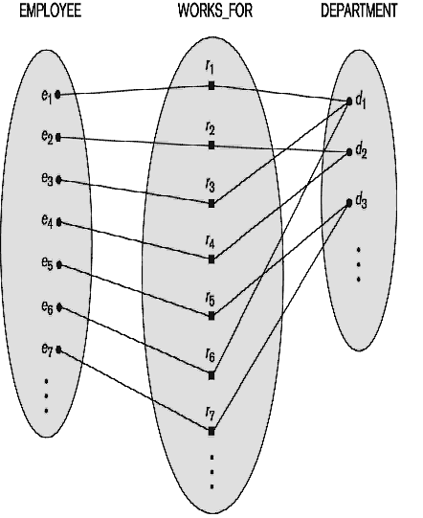

Relationship Instances of the M:N WORKS_ON

Relationship between EMPLOYEE and PROJECT

EMPLOYEE WORKS_ON PROJECT
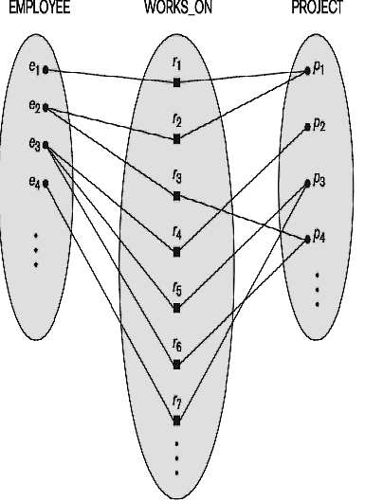

Relationship Type vs. Relationship Set

- Relationship Type:
  - Is the schema description of a relationship
  - Identifies the relationship name and the participating entity types
  - Also identifies certain relationship
constraints
- Relationship Set:
  - The current set of relationship instances represented in the database
  - The current state of a relationship type
- In ER diagrams, we represent the
relationship type as follows:
  - Diamond-shaped box is used to display a relationship type
  - Connected to the participating entity types via straight lines

Refining the COMPANY Database Schema by Introducing Relationships
- By examining the requirements, six relationship types are identified
- All are binary relationships (degree 2)
- Listed below with their participating entity types:
  - WORKS_FOR (between EMPLOYEE,
DEPARTMENT)
  - MANAGES (also between EMPLOYEE, DEPARTMENT)
  - CONTROLS (between DEPARTMENT, PROJECT)
  - WORKS_ON (between EMPLOYEE, PROJECT)
  - SUPERVISION (between EMPLOYEE (as
subordinate), EMPLOYEE (as supervisor))
  - DEPENDENTS_OF (between EMPLOYEE, DEPENDENT)

Discussion on Relationship Types

- In the refined design, some attributes from the initial entity types are refined into relationships:
  - Manager of DEPARTMENT -> MANAGES
  - Works_on of EMPLOYEE -> WORKS_ON
  - Department of EMPLOYEE -> WORKS_FOR
  - etc
- In general, more than one relationship type can exist between the same participating entity types
  - MANAGES and WORKS_FOR are distinct relationship types between EMPLOYEE and DEPARTMENT
  - Different meanings and different relationship instances.
- Each entity type that participates in a relationship type plays a particular role in the relationship

Recursive Relationship Type

- A relationship type where the same entity type participates more than once in the relationship in distinct roles is called recursive relationship
- Example: the SUPERVISION relationship
- EMPLOYEE participates twice in two distinct roles:
  - supervisor (or boss) role
  - supervisee (or subordinate) role
- Each relationship instance relates two distinct EMPLOYEE entities:
  - One employee in supervisor role
  - One employee in supervisee role

Displaying a Recursive Relationship

In a recursive relationship type.

Both participations are same entity type in different roles.

For example, SUPERVISION relationships between EMPLOYEE (in role of supervisor or boss) and (another) EMPLOYEE (in role of subordinate or worker).
  - In following figure, first role participation labeled with 1 and second role participation labeled with 2.
  - In ER diagram, need to display role names to distinguish participations.
A Recursive Relationship Supervision
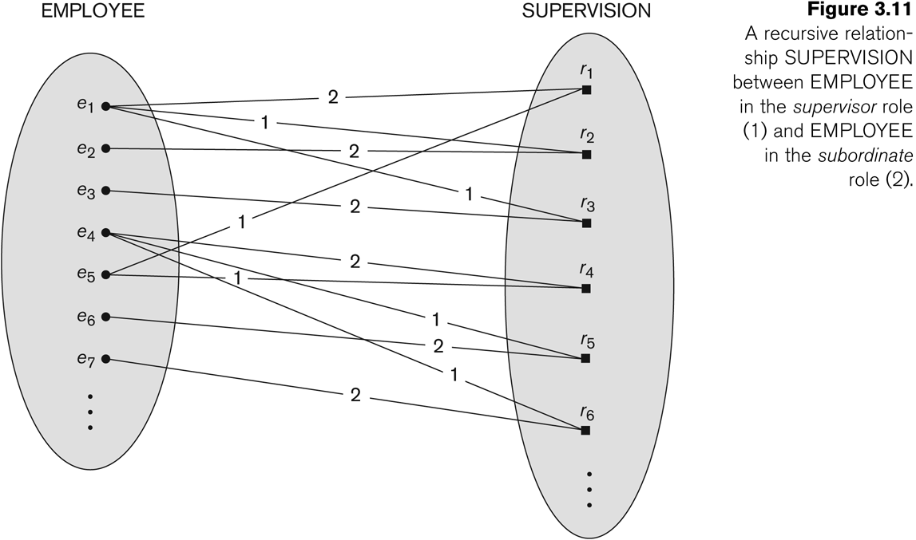
Recursive Relationship type is : SUPERVISION (participation role names are shown)
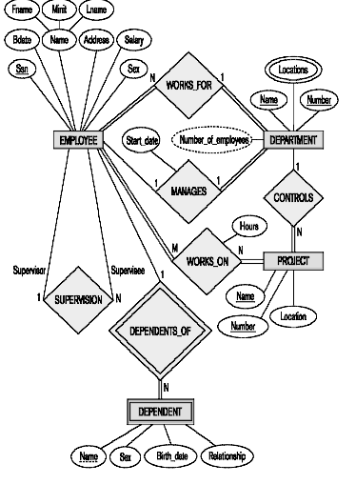

Weak Entity Types

- An entity that does not have a key attribute
- A weak entity must participate in an identifying relationship type with an owner or identifying entity type
- Entities are identified by the combination of:
  - A partial key of the weak entity type
  - The particular entity they are related to in the identifying entity type
- Example:
  - A DEPENDENT entity is identified by the dependent’s first name, and the specific EMPLOYEE with whom the dependent is related
  - Name of DEPENDENT is the partial key
  - DEPENDENT is a weak entity type
  - EMPLOYEE is its identifying entity type via the identifying relationship type DEPENDENT_OF
- A week entity type and its identifying relationship are distinguished by surrounding their boxes and diamonds with double lines
- The partial key attribute is underlined with a dashed or dotted line
Constraints on Relationships
- Constraints on Relationship Types
  - Cardinality Ratio (specifies maximum
participation)
    - One-to-one (1:1)
    - One-to-many (1:N) or Many-to-one (N:1)
    - Many-to-many (M:N)
  - Existence Dependency Constraint (specifies minimum participation) (also called participation constraint)
    - zero (optional participation, not existence- dependent)
    - one or more (mandatory participation, existence-dependent)

Many-to-One (N:1) Relationship
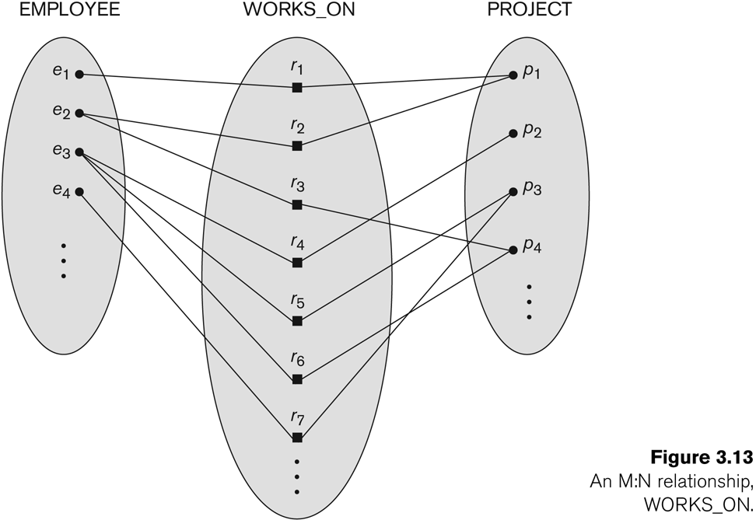
Many-to-Many (M:N) Relationship



Attributes of Relationship Types
- A relationship type can have attributes:
  - For example, HoursPerWeek of WORKS_ON
    - Its value for each relationship instance describes the number of hours per week that an EMPLOYEE works on a PROJECT.
    - A value of HoursPerWeek depends on a
particular (employee, project) combination
  - Most relationship attributes are used with M:N relationships
    - For M:N relationships, some attributes are determined by the combination of participating entities, not by a single entity. Such attributes must be specified as relationship attributes
    - In 1:1 relationships, they can be transferred
to one of the participating entities
    - In 1:N relationships, they can be transferred to the entity type on the N-side of the relationship
    - The decision as to where a relationship attribute should be placed is determined subjectively by the schema designers

Example Attribute of a Relationship Type: Hours of WORKS_ON

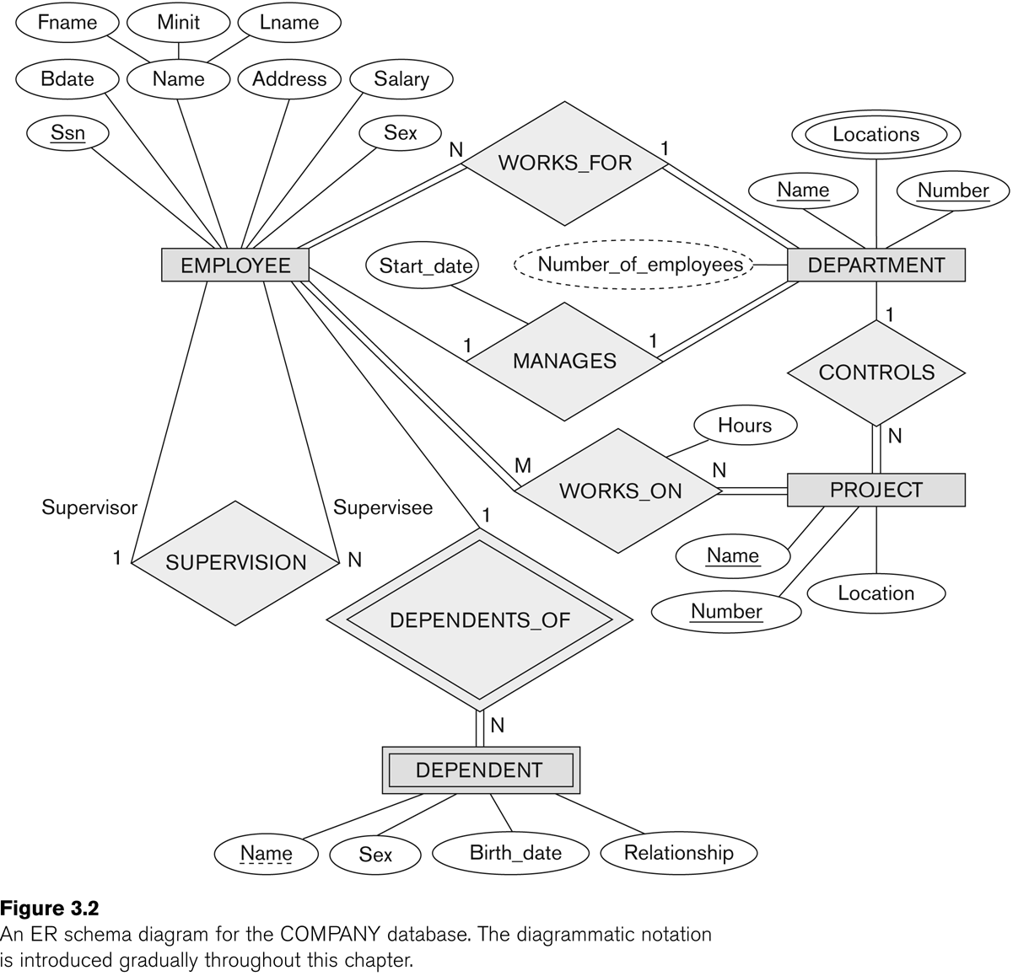
Notation for Constraints on Relationships

- Cardinality ratio (of a binary relationship): 1:1, 1:N, N:1, or M:N
  - Shown by placing appropriate numbers on the relationship edges.
- Participation constraint (on each participating entity type): total (called existence dependency) or partial.
  - Total shown by double line, partial by single line.
- NOTE: These are easy to specify for Binary Relationship Types.
- Structural Constraints = Cardinality Ratio Constraints + Participation Constraints

Alternative (min, max) Notation for Relationship Structural Constraints
- Specified on each participation of an entity type E in a relationship type R
- Specifies that each entity e in E participates in at least min
and at most max relationship instances in R
- Default (no constraint): min=0, max=n (signifying no limit)

- Must have min<=max, min>=0, max >=1
  - min=0 implies partial participation; min>0 implies total participation
- Derived from the knowledge of mini-world constraints
- Examples:
  - A department has exactly one manager and an employee can manage at most one department.
    - Specify (1,1) for participation of DEPARTMENT in MANAGES
    - Specify (0,1) for participation of EMPLOYEE in MANAGES
  - An employee can work for exactly one department but a department can have any number of employees.
    - Specify (1,1) for participation of EMPLOYEE in WORKS_FOR
    - Specify (1,n) for participation of DEPARTMENT in WORKS_FOR

The (min,max) Notation for Relationship Constraints

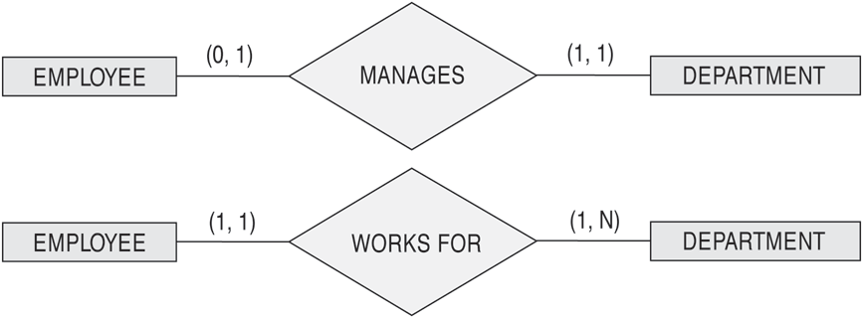

- Read the min,max numbers next to the entity type and looking away from the entity type

Summary of Notation for ER Diagrams

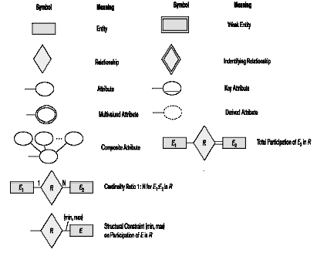

COMPANY ER Schema Diagram Using (min, max) Notation
